
2. Aetiologies of Depression

What is Depression?
Read the description on page 229 and identify the key words/terms

What is the difference between unipolar depression and bipolar depression?
__________________________________________________________________________________________________________________________________________________________________________
90% of people who have a type of depression are unipolar not bipolar.

Another distinction can be made between unipolar depression; reactive or endogenous. Reactive depression can be triggered by a stressful event such as the death of a friend. Endogenous depression is caused from within the person, for example hormone imbalance.

NOTE: As with schizophrenia, you do not need to know in depth characteristics of depression for the exam. You will only be asked about aetiologies or treatments. However, you could start your essay with a brief description of what depression is, so long as the emphasis is on the aetiology or treatment.

You need to know about two types of explanation for depression: biological and psychological.
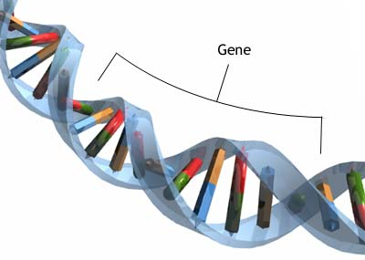
Biological explanations: GENES

As with schizophrenia, there are three main kinds of study to determine whether depression has a genetic basis; twin studies, adoption studies and family studies.

TWIN STUDIES
In the population at large, the average rate of depression is about 5%. Therefore, if there is a genetic aspect, we would expect identical twins to have a much higher concordance rate.

- Allen (1976): Concordance rates for unipolar depression: 40% for MZ twins, 11% for DZ twins.
- Bertelsen, Harvald and Hauge (1977): concordance rates for unipolar depression 80% for MZ, 16% for DZ.
- McGuffin et al (1996): ________________________________________ __________________________________________________________
What does this research suggest? _________________________________________________________ __________________________________________________________________________________________________________________________________________________________________________


FAMILY STUDIES
Similarly to twin studies, if depression was caused by genetic factors, we would expect it to run in families. The closer you are genetically to someone in your family, the more likely you will be to have depression.

Gershon (1990) presented the findings of a number of studies into the rates of depression within families. The rates of depression for individuals with a first degree relative with depression was about two to three times higher than in the general population. Similar results were found by Sullivan (2000).

What is a major issue with drawing conclusions from twin and family studies? _______________________
_______________________________________________________________________________________________________________________________________________________________________________________________________________________________________________________________

Could there be another explanation as to why you are more likely to have depression if you have a close relative with the illness?
____________________________________________________________________________________________________________________________________________________________________________________________________________________________________________________________________________________________________________________________________________________

ADOPTION STUDIES
One way of overcoming the limitations of the studies above is to look at concordance rates in family members reared apart.


Wender (1986) found that the biological relatives of adopted sufferers of depression were about seven times more likely than their adopted relatives to have had major depression themselves. He also found that with adopted children who went on to develop depression, their biological parents were eight times more likely to have depression than their adoptive parents.

Can we generalise from adopted individuals to the general population? ____________________________ __________________________________________________________________________________________________________________________________________________________________________

- One issue with adoption studies is that children are often placed in adopted homes that are very similar to their birth family. This confuses the issue of genes and environment.

All of the evidence seems to suggest that depression has some genetic basis. However, an issue with the theory that depression is completely due to genetic factors is that we would expect the concordance rates for identical twins to be 100%. Identical twins have identical genes, meaning that they should have identical illnesses. Something else must be happening to explain the low concordance rate.

Comorbidity
It may be that the genes that cause depression are also responsible for other disorders. Therefore, there may be a relationship between depression and other psychological conditions. This is called comorbidity, and describes the concordance of two or more different conditions.

What did Kendler (1992) find? ________________________________________________ _________________________________________________________________________ _________________________________________________________________________ _________________________________________________________________________

Diathesis Stress
One potential way to explain this issue would be to apply the diathesis stress model to depression. What is the diathesis-stress model?
_______________________________________________________________________________________________________________________________________________________________________________________________________________________________________________________________

Kendler (1995) investigated the concordance of depression in twins.
Which bits of his research supports the diathesis: ____________________________________________ __________________________________________________________________________________________________________________________________________________________________________
Which bits support the stress?: ___________________________________________________________ __________________________________________________________________________________________________________________________________________________________________________

If genes do act as a diathesis, then we should be able to identify which genes are responsible for depression. One possible gene is the serotonin transporter gene. People who have the short-short version of his gene have a reduced ability to produce serotonin, which may possible lead to depression.

Wilhelm (2006) investigated the role of genes and life events in the onset of depression.
Which bits of his research supports the diathesis: ____________________________________________ __________________________________________________________________________________________________________________________________________________________________________
Which bits support the stress?: ___________________________________________________________ __________________________________________________________________________________________________________________________________________________________________________
Any problems with this research? __________________________________________________________ __________________________________________________________________________________________________________________________________________________________________________

Other Biological Explanations

- Pg 236-237 in the book has an alternative biological explanation which is to do with neurotransmitters

Psychological explanations: PSYCHODYNAMIC THEORIES

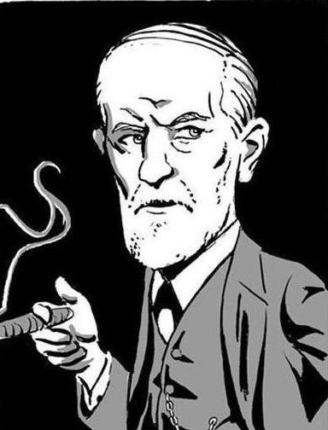
Freud (1917) put forward an explanation of depression based on ideas and concepts from the psychodynamic approach. Freud argued that depression is like grief, in that if often occurs in reaction to the loss of an important relationship. However, there is an important difference, because the depressed people regard themselves as worthless. What happens is that the individual identifies with the lost person, so that repressed anger towards the lost person is directed inwards towards the self. This inner-directed anger reduces the individuals self esteem and makes him or her vulnerable to experiencing depression in the future.

Freud distinguished between actual losses (death of a loved one) and symbolic losses (the loss of a job). Both kinds of losses can produce depression by causing the individual to re-experience childhood episodes when they experienced loss of affection from some significant person, usually a parent. Therefore, depression should be higher in people who had experienced a loss as a child

Evidence
What did Shah and Waller (2000) find? _____________________________________________________ __________________________________________________________________________________________________________________________________________________________________________
Can you think of an alternative explanation for this research? ____________________________________ _______________________________________________________________________________________________________________________________________________________________________________________________________________________________________________________________


Bifulco et al (1992): Women who had lost their mother as a child (either through separation or death) were more likely to suffer anxiety and depression as adults. This seems to suggest that the early loss of a parent can lead to later depression. But is the later depression necessarily caused by the death of the parent, or could other factors be involved?
_______________________________________________________________________________________________________________________________________________________________________________________________________________________________________________________________________________________________________________________________________________________________________________________________
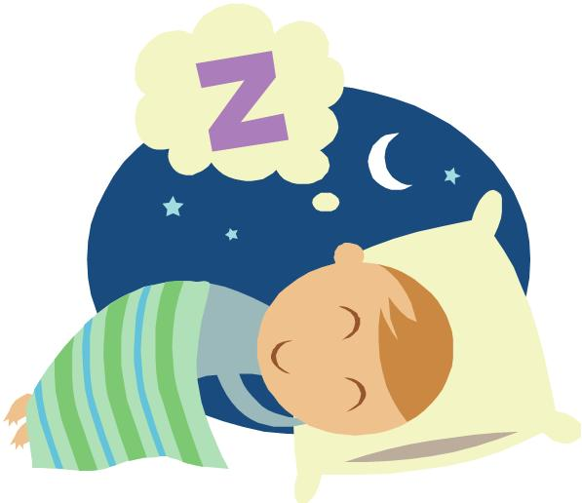

Another issue with Freud’s theory is that according to psychodynamic principles, the repressed anger and hostility felt by depressed people would emerge in their dreams. However Beck and Ward (1961) found no evidence of this.


Also, Freud predicted that depressed people would express their anger and hostility mainly towards themselves. In fact Weissman et al (1971) found that they express considerable anger and hostility to those around them.

Finally, Freud’s theory can not be a complete explanation of depression. Why?
_______________________________________________________________________________________________________________________________________________________________________________________________________________________________________________________________

Psychological explanations: COGNITIVE THEORIES

Learned helplessness

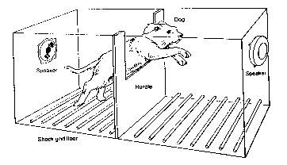
Seligman (1975) proposed that depression can be explained by learned helplessness. He first discovered learned helplessness in his experiments on animals (mainly dogs). The dog was placed into a cage (right) where one side was an electrified floor. The dog would receive a painful shock through the floor, and would quickly learn that to escape the shock he could jump over the barrier. However, if the barrier was made too high for the dog to jump, the dog soon accepted that the shocks were unavoidable, and became listless and passively accepted the shocks. When the barrier was lowered again, and escape became possible, the dos still did not try to escape. They had learned to be helpless. Seligman argued that this is what happens in depressed people.

Describe how learned helplessness can explain the behaviour of depressed people. __________________ _______________________________________________________________________________________________________________________________________________________________________________________________________________________________________________________________
However, what is an issue with this research? _______________________________________________ _____________________________________________________________________________________

Abramson (1978) developed this idea of learned helplessness, but altered it to focus upon the thoughts of people who experience learned helplessness. He stated that people can respond to failure in a number of ways:
- Individuals either attribute the failure to an internal cause (something within them such as personality or skill), or external (other people, or the circumstances).
- The cause of the failure is either stable (likely to continue in the future) or unstable (might easily change in the future).
- Individuals attribute the failure to a global cause (applying to a wide range of situations) or a specific cause (applying to one situation).

How do people with learned helplessness attribute their failures? _________________________________ _____________________________________________________________________________________

You have just broken up with your girlfriend/boyfriend. If you had a depressive attribution style, how might you attribute this event? _____________________________________ ______________________________________________________________________ ______________________________________________________________________ ______________________________________________________________________ What about someone who was not depressed? ________________________________ __________________________________________________________________________________________________________________________________________________________________________

Cause and effect? ______________________________________________________________________ _____________________________________________________________________________________

Lewinsohn et al (2001) studied adolescents who experienced many negative life events over a 12 month period. Those who had strongly negative attributions at the start of the study were much more likely to develop major depression than those who initially did not have negative attributions.
This suggests: _________________________________________________________________________ _____________________________________________________________________________________

Beck’s Theory of depression

Negative self schema: a self-schema is a packet of information that we have about ourselves. It contains the thoughts, feelings and knowledge that we have about ourselves. According to Beck, we acquire a set of beliefs about ourselves through early experiences, in particular involving our parents. If these experiences are negative, then so will be our self schema. We will then interpret new information relevant to ourselves in the light of our existing self schemas. Once we have a negative self schema, it becomes difficult for us to interpret any new information about ourselves positively.

When a person encounters a new situation that resembles the original conditions when the schemas were learned, they will interpret it negatively.

Original event: showing your mum a picture that you drew at school, and she shouts at you, tells you it is no good and rips it up in front of you
Self schema made: “I am useless and anything that I produce is worthless.”
New event: having to complete a piece of coursework for school
Interpretation in light of existing self schema: _____________________________________________ __________________________________________________________________________________________________________________________________________________________________________

Beck’s cognitive triad: Beck argued that these negative self schemas cause us to view ourselves, the world and the future negatively. This is known as the Cognitive Triad.

Complete the diagram of the triad below, giving an example of something a depressed person may think.

This type of thinking can lead individuals to pay more attention to the negative aspects of situations, and ignore the positive. The glass is always “half empty”. It can be difficult for individuals to be able to break out of this pattern of negative thinking.

There is more information on cognitive errors in the magazine article on CBT.

- While there is little doubt that depressed people do experience the sort of negative thoughts discussed above, there is an issue with regards to causality. Do the negative thoughts lead to the depression, or does the depression lead to the negative thoughts?
  - Most of the evidence suggests that negative thoughts and attitudes are caused by depression rather then being the cause.
  - Lewinsohn (1981) carried out a prospective study in which negative thoughts were assessed before any of the participants became depressed. He concluded that there was no relationship between negative thought and irrational beliefs and future depression.

- However Nolen-Hoeksma et al (1992) found that a negative attribution style in older children predicted later depression, but only in the children who experienced stressful life events.
  - This might mean that negative thoughts make people vulnerable to depression, but there still needs to be an environmental trigger.
  - However, is it definitely the negative thoughts which lead to the depression, or could there
be a third factor? ___________________________________________________________ ___________________________________________________________________________________________________________________________________________________________________________________________________________________________

- A strength of cognitive theories of depression is that therapies based on these cognitive assumptions are quite successful for depression.
  - However, we must be careful about suggesting that the success of a treatment reveals the cause of a disorder. This is called the treatment-aetiology fallacy.

We have looked at some explanations for depression, including both biological and psychological. Is there any way we can combine two or more of these explanations together to create a more rounded explanation of depression? Could one of these explanations tell us how depression starts, and another tells us how it is maintained?

